**Unit-4**

**Human Resource Accounting**

**Definition**

Human resource accounting is the art of valuing, recording, and presenting the work of all human resources in an organization’s accounts. It can help management make vital decisions about selection, layoff, transfer, training, and promotion.

“Human resource accounting is the process of identifying and measuring data about human resources and communicating this information to interested parties.” – American Accounting Association (1973).

“Human resource accounting is an attempt to identify and report investments made in human resources of an organization that the presently not accounted for in a conventional system that tells the management what changes over time are occurring to the business’s human resources.” – Woodruff (1970)

## **Objectives of Human Resource Accounting**

Some of the objectives of human resource accounting should fulfil include:

* [**Produce information of cost and value of Human Resource**](https://www.geektonight.com/human-resource-accounting/#produce-information-of-cost-and-value-of-human-resource)
* [**Effectively monitor the use of Human Resource**](https://www.geektonight.com/human-resource-accounting/#effectively-monitor-the-use-of-human-resource)
* [**Appreciation and Depreciation of Human Resource**](https://www.geektonight.com/human-resource-accounting/#appreciation-and-depreciation-of-human-resource)
* [**Provide the cost and value information**](https://www.geektonight.com/human-resource-accounting/#provide-the-cost-and-value-information)

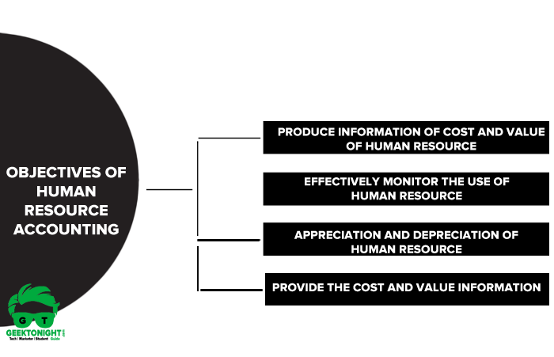

### **Produce information of cost and value of Human Resource**

The main aim of HR Accounting is to generate cost and value information of human resources by measuring and identifying the data about the employees or managers working in an organization.

### **Effectively monitor the use of Human Resource**

Human Resource Accounting helps the organization to make the best employment of human resources and keep a constant check on the performance of human resources. It ensures that whatever cost management has incurred in acquiring, selecting or training the employees is justified.

### **Appreciation and Depreciation of Human Resource**

HRA is also considered as an accounting system that treats employees as the biggest asset of the organization. Their level of performance and quality of work is recorded in the books of an organization.

### **Provide the cost and value information**

Human Resource Accounting as it is clear from its meaning is an activity of knowing cost invested in employees towards their recruitment, training, [**payment of wages**](https://www.geektonight.com/payment-of-wages-act-1936/) and salaries and other benefits paid in return of their contribution towards the organization. This cost and value analysis is very useful for the organization

## **Advantages of Human Resource Accounting**

[Advantages of human resource accounting](https://www.geektonight.com/human-resource-accounting/#advantages-of-human-resource-accounting) are mentioned below:

* [**Helps in decision making**](https://www.geektonight.com/human-resource-accounting/#helps-in-decision-making)
* [**Identifies the strength and weakness of the existing workforce**](https://www.geektonight.com/human-resource-accounting/#identifies-the-strength-and-weakness-of-the-existing-workforce)
* [**Measures the effectiveness of the HR policies**](https://www.geektonight.com/human-resource-accounting/#measures-the-effectiveness-of-the-hr-policies)
* [**Helps investors judge a company**](https://www.geektonight.com/human-resource-accounting/#helps-investors-judge-a-company)
* [**Measures the return in investment**](https://www.geektonight.com/human-resource-accounting/#measures-the-return-in-investment)

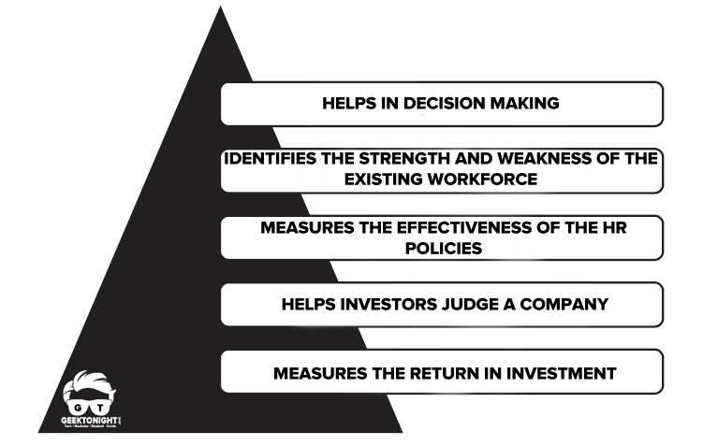

### **Helps in decision making**

Human Resource Accounting helps in taking appropriate decisions regarding human assets in the organization.

Whether to recruit a new employee or to promote the employee internally?  
Whether to transfer the employees to a new location or hire employees locally?  
Whether to incur additional costs in training the existing employees or hire consultants from outside?

### **Identifies the strength and weakness of the existing workforce**

Human Resource Accounting helps in identifying the strength and weakness of the existing manpower in the organization. This will help the management in taking decision regarding

1. Manpower planning
2. Training and development
3. Transfers
4. Promotions
5. Retrenchment of the employees

### **Measures the effectiveness of the HR policies**

Implementation of Human Resource Accounting system enables the management to assess the effectiveness of its HR policies. If the management is incurring high cost on the recruitment of employees, it can change the method of recruitment.

### **Helps investors judge a company**

The cost and value information provided by different organizations by the way of Human Resource Accounting will help the investors to identify the right company for the purpose of their investment.

### **Measures the return in investment**

Human Resource data also helps in the measurement of ROI. The organization makes investment on its employees with the expectations of generating returns. It should make sure that the company’s return on investment on its Human Resources should be greater than the investment in them in terms of recruitment, training and development etc.

## **Limitations of Human Resource Accounting**

HRA is yet to gain momentum in India due to certain difficulties:

* The valuation methods have certain disadvantages as well as advantages; therefore, there is always a bone of contention among the firms that which method is an ideal one.
* There are no standardized procedures developed so far. So, firms are providing only as additional information.  
  Under conventional accounting, certain standards are accepted commonly, which is not possible under this method.
* All the methods of accounting for human assets are based on certain assumptions, which can go wrong at any time. For example, it is assumed that all workers continue to work with the same organization till retirement, which is far from possible.
* It is believed that human resources do not suffer depreciation, and in fact they always appreciate, which can also prove otherwise in certain firms.
* The lifespan of human resources cannot be estimated. So, the valuation seems to be unrealistic.

## **Methods of Human Resource Accounting**

Several methods have been in use but they all fall under [**methods of human resource accounting**](https://www.geektonight.com/methods-human-resource-accounting/#methods-of-human-resource-accounting):

* [**Historical Cost Method**](https://www.geektonight.com/methods-human-resource-accounting/#historical-cost-method)
* [**Replacement Cost Method**](https://www.geektonight.com/methods-human-resource-accounting/#replacement-cost-method)
* [**Present Value Method and Economic Value Method**](https://www.geektonight.com/methods-human-resource-accounting/#present-value-method-and-economic-value-method)
* [**Asset Multiplier Method**](https://www.geektonight.com/methods-human-resource-accounting/#asset-multiplier-method)

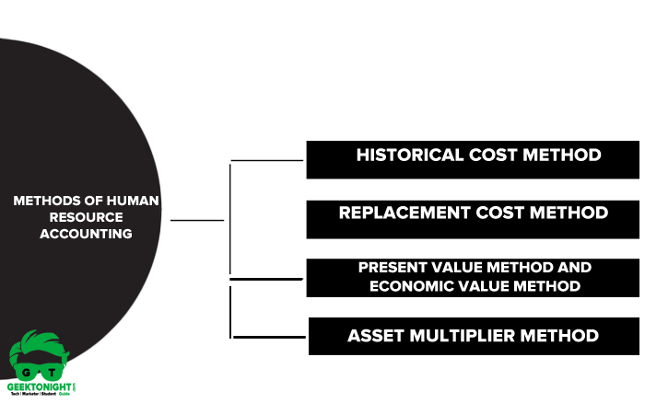

### **Historical Cost Method**

Under the [Historical cost method](https://www.geektonight.com/methods-human-resource-accounting/#historical-cost-method), the sum of all the costs related to human resources is calculated to find out the value of a human resource. These costs include the cost of recruitment, selection, training, placement, and development of human resources of an organization.

[Historical Cost Method](https://www.geektonight.com/methods-human-resource-accounting/#historical-cost-method) was introduced by Brummet, Flamholtz and Pyle. This is the oldest method of valuation of human resources.

#### **Types of Historical Cost Method**

**Acquisition cost**: It means the cost which is incurred on acquiring the human resource in the organization. The cost incurred at the time of recruitment, selection, and placement, etc.  
**Learning Cost:** It means that cost is incurred at the time of providing training and development to the employees and managers.

#### **Advantage of historical cost method**

* This method is very easy to calculate the value of a human resource.
* Employers and employees can easily understand this method.
* This method follows the traditional accounting concept of matching costs with revenue.
* Return on the company’s investment in human resources can easily be calculated by this method.

**Disadvantages of Historical Cost Method**

* Under this method it is very different to estimate the service period of an employee.
* In this method rate of amortization is very difficult to determine.
* As we know, the value of assets decreases with an increasing number of years or amortization. But in the case of human resources, it is just the opposite. The utility of employees increases with the increasing experience and training provided to them.

### **Replacement Cost Method**

[Replacement cost](https://www.geektonight.com/methods-human-resource-accounting/#replacement-cost-method) is that cost which is incurred on replacing the existing human resource by an identical one i.e. human resource capable of rendering similar services.

Replacement Cost Method was introduced by Rensis Likert and Eric G. Flamholtz.

This method is different from the historical cost method.  
The historical method takes into account only the sunk cost which is immaterial to calculate the value of human resources and take a decision on that basis.  
The replacement cost method is very realistic as it considers the current value of human resources in its financial statement.

#### **Advantage of replacement cost method**

* This method estimates the present value of human resources. This method is very logical and representative.
* This method can easily adjust the human value of price trends and can provide real value at the time of the rise in prices.

#### **Disadvantage of replacement cost method**

* The identical replacement of an employee is not always possible to find.
* The cost of replacing the human resource is inconsistent with traditional accounting system based on the cost concept.

### **Present Value Method and Economic Value Method**

[Present value method](https://www.geektonight.com/methods-human-resource-accounting/#present-value-method-and-economic-value-method), the future earnings of the employees are estimated up to the retirement period and is discounted at a discount rate which is usually the cost of capital.

Economic value method present worth of the employee is calculated on the basis of the future service that is expected from him till his retirement.

Under this methods value of a human resource is calculated on the basis of the contribution made by the employees in the organization till their retirement. The payment due to the employees in the form of pay, allowance, and benefit etc. are estimated and then discounted to arrive at a present economic value of the individual.

#### **Advantage of economic value method**

* Employees’ career movements are considered under this method.
* The possibilities of employees leaving the organization other than death or retirement are also considered.

#### **Disadvantage of economic value method**

* The service tenure of an employee is very difficult to estimate.
* The value of expected services data is very difficult to find.
* Estimation of an employee’s chances of occupying various positions for each employee is not an easy task.
* Valuation of the contribution of services from employees is also not easy to judge.
* To estimate the exit probabilities and changes from one position to another is an expensive process.

### **Asset Multiplier Method**

[Asset Multiplier Methods](https://www.geektonight.com/methods-human-resource-accounting/#asset-multiplier-method) consider that there is no direct relationship between the cost incurred on human resources and how much value he is for the organization. The value of human resources depends on various factors like the level of motivation and employee attitude towards work and organization.

Here multiplier refers to instruments that relate personal worth of human resource to the total asset value of the organization.

Employees of the organization are divided into four categories under this method namely

* Top management
* Middle management
* Supervisor
* Clerical employees.

Asset Multiplier reflects the following factors:

* Technical, qualification and experience of employees.
* Experience required for the job.
* Personal qualities and attitude.
* Loyalty and expectation of future services.

#### **Advantage of asset multiplier method**

* This method is simple and easy to understand.
* Data for calculation is easily available.
* Multipliers used in this method are different for a different group of employees.

#### **Disadvantage of asset multiplier method**

* This method considers factors like motivation and employee’s attitude which are difficult to quantify.

# **Career Management**

**Career management is conscious planning of one’s activities and engagements in the jobs one undertakes in his life for better fulfilment, growth and financial stability.** It is a sequential process that starts from an understanding of oneself and encompasses occupational awareness.

Career management is the capability of proactively and strategically planning and running your career. It is about improving self-[awareness](https://www.marketing91.com/awareness/) so that a person knows his preferences, priorities, work values as well as strengths to have an exact [idea](https://www.marketing91.com/swot-analysis-idea/) of his future goals.

In this fast-changing world, hiring managers are looking for two things in the employees.

The first is that they can set goals and have the ability to go after them and succeed. Second, they have the necessary tactical [skills](https://www.marketing91.com/skills/) to undertake appropriate action, for instance, problem-solving, [decision making](https://www.marketing91.com/decision-making/) and networking, etc.

## **Components of a career management System**

The key components of a career [management system](https://www.marketing91.com/management-system/) are as follows-

* Support from top management
* Periodic assessment of skills and know-how
* Open enrolment
* Full involvement of supervisors and managers in the process
* Coordination with activities related to human resource
* Using managers from the human resource as consultants
* Periodic assessment of programs
* Onus on success
* Realistic feedback related to career progress

## **Career management process**

The career management process is about investing resources to accomplish your goals and objectives. It includes several concepts that are described below-

**1. Self-awareness**

This is the first step in the career management system and provides self-introspection. What are your interests, what is essential for you, what are the things you value, what are the things you like, what are your unique skills etc. are some questions that need to be answered in this phase for discovering specific things about yourself.

All these questions are the means to find your values, traits, interests, and skills so that a person can set his goals for the future.

**2. Career exploration/**[**career development**](https://www.marketing91.com/plan-career-development-employees/) **planning**

The career development planning or career exploration is a recurring process that includes the following steps –

* **Career values –** It is essential to integrate work values with overall life values to know what is necessary for you in life. It is the work values that acts as a guiding force and helps to focus on the essential things. An individual who is happy and satisfied in personal life will quickly achieve better [productivity](https://www.marketing91.com/productivity/). Remember, work values keep on changing at intervals, and it becomes essential to keep on reassessing them regularly for overall job success.
* **Work preferences –** Work preferences play a significant role in career development planning. It is a personal choice, and it is quite natural for two people to have different work preferences in life. Dig deeper to assess and identify work preferences and, if necessary, take the help of assessment tools for your purpose.
* **Strengths –** Understand your strengths if you are interested in career exploration/career development planning. Look for positive qualities like hard-working, detail-oriented, excellent [communication](https://www.marketing91.com/what-is-communication/) skills, and also specific traits like good at decision making, [soft skills](https://www.marketing91.com/soft-skills-definition-meaning-types-importance/), etc. to develop your full potential. The more specific your abilities and qualities are, the more you will [be successful](https://www.marketing91.com/how-to-be-successful/) in the job interviews.
* **Weakness –** Just like strengths, it is also essential to identify your weakness if you are interested in career exploration/career development planning. Hiring managers pay special attention to the weakness of the applicants, and often one of the job [interview questions](https://www.marketing91.com/interview-questions/) is what do you consider your weakness. An honest understanding of your weakness will help you in overcoming them in time so that you are not embarrassed by it at any moment. Do not be overly self-critical as this step is designed so that a person can call attention to perceived weaknesses and take matters in hand to eliminate them.

**3. Lifelong** [**learning**](https://www.marketing91.com/learning/)

Technology is reigning supreme in all the spheres of our life. All the technical devices like tablets, phones, and computers have become necessary in the workplace and often determine how we are managing our work life.

Adapt to the ongoing innovations and devices by updating your skills and know-how regularly.

**4. Networking**

One of the most critical aspects of career exploration/career development planning is effective networking. It is an essential asset that can take your career a step further. Develop and hone your ability to connect and interact with important people.

Building a good and strong relationship will have a direct impact on career opportunities in the future.

## **Objectives**

The objectives of the career management system are as follows-

* The objective of the career management process is to help in improving the performances of the employees. It involves them in identifying strengths and weaknesses for setting desired goals. It also encourages employees to recognize the need for training and to provide ample opportunities for its achievement if necessary.
* The objective of the career management process is to integrate and align the goals of the employees with those of the organization. It helps to find the right fit in the organization by matching the right person with the right job profile. It encourages several practices like rotation and transfers to different departments within the organization to [boost](https://www.marketing91.com/marketing-mix-boost/) efficiency and productivity. It improves the capabilities of its existing employees so that there is very little need to hire employees from outside.
* The career management process's objective is to inform employees about the available career options in the organization. It also helps the employees to identify the skills and know-how needed for jobs in the present scenario and the future. Career management helps to develop and enhance the [career path](https://www.marketing91.com/career-path/) of the employees.
* The objective of the career management process from the [employer](https://www.marketing91.com/employer/)’s viewpoint is that it ensures the availability of a pool of skilled and competent employees in the organization.

## **Need of Career Management**

The advantages of career management are as follows-

* The career management program ensures a regular supply of professional talent to fulfill the goals and objectives of a [company](https://www.marketing91.com/business-model-of-a-company/). [Staffing](https://www.marketing91.com/staffing/) inventories is one of its significant advantages
* The advantage of implementing a career management program in an organization is that it encourages staffing from within the company.
* One of the essential advantages of the career management process is that it helps an [employee](https://www.marketing91.com/employee-definition-types-meaning/) to set realistic goals
* An effective career management program is a remedy to solve staffing issues.
* The advantage of implementing a career management program in an organization is that it minimizes the rate of [employee turnover](https://www.marketing91.com/what-is-employee-turnover/) and boosts [employee retention](https://www.marketing91.com/employee-retention/).
* The career management process provides better opportunities for career growth to the employees in an organization.
* Career management is a step in the right direction as it improves [employee engagement](https://www.marketing91.com/employee-engagement/) and [employee satisfaction](https://www.marketing91.com/employee-satisfaction/) in an organization. This leads to enhanced [employee motivation](https://www.marketing91.com/what-is-employee-motivation/).
* The advantage of implementing a career management program in an organization is that it encourages [employment](https://www.marketing91.com/employment-definition-and-meaning-in-human-resources/) equity through appropriate placement and selection during the recruitment process. It abolishes discriminatory practices related to promotions and raise.

**Stress Management**

**Meaning and Definition of Stress:**

**Meaning:** Stress is the body's response to external or internal pressures, often referred to as stressors. These pressures can be physical, emotional, or psychological in nature.

**Definition:** Stress can be defined as a state of mental or emotional strain resulting from demanding circumstances. It can manifest as feelings of tension, worry, or overwhelm.

**Importance of Managing Stress:**

**Health and Well-being:** Chronic stress can have detrimental effects on physical and mental health, including increased risk of heart disease, depression, anxiety, and other health issues.

**Productivity and Performance:** High levels of stress can impair cognitive function, decision-making, and job performance, leading to decreased productivity and effectiveness.

**Workplace Morale:** A stressful work environment can negatively impact morale, job satisfaction, and employee engagement, leading to higher turnover rates and decreased organizational effectiveness.

**Costs to the Organization:** Stress-related absenteeism, turnover, and healthcare costs can have significant financial implications for organizations.

**Potential Sources of Stress**:

**Workload:** High job demands, tight deadlines, and excessive workload.

**Interpersonal Relationships:** Conflict with colleagues, supervisors, or clients.

**Organizational Changes:** Restructuring, layoffs, mergers, or changes in leadership.

**Job Insecurity:** Fear of job loss or instability.

**Role Ambiguity:** Unclear job expectations or responsibilities.

**Work-Life Balance:** Difficulty balancing work and personal life responsibilities.

**What is Stress Management:**

**Definition:** Stress management refers to the techniques and strategies used to cope with and reduce the negative effects of stress on individuals and organizations.

**Goal:** The goal of stress management is to enhance resilience, improve coping skills, and create a supportive environment that promotes well-being and productivity.

**Consequences of Stress**:

**Physical Health Effects**: Headaches, muscle tension, fatigue, insomnia, digestive issues, and weakened immune system.

**Mental Health Effects:** Anxiety, depression, irritability, mood swings, and difficulty concentrating.

**Behavioral Effects:** Increased use of alcohol or drugs, social withdrawal, aggression, or changes in eating habits.

**Interpersonal Effects:** Strained relationships with colleagues, friends, or family members.

**Workplace Effects:** Decreased job satisfaction, absenteeism, turnover, decreased productivity, and increased risk of accidents or errors.

**Managing Stress:**

**Identify Stressors:** Recognize and understand the sources of stress in your life or workplace.

**Develop Coping Strategies:** Practice relaxation techniques, mindfulness, exercise, and time management skills.

**Seek Support:** Talk to friends, family, or colleagues for support, or seek professional help if needed.

**Set Boundaries**: Establish healthy boundaries between work and personal life to maintain balance.

**Practice Self-Care:** Take care of your physical and mental well-being through healthy habits, hobbies, and activities.

**Create a Supportive Environment**: Encourage open communication, promote work-life balance, and implement stress management initiatives in the workplace.

By effectively managing stress, individuals and organizations can minimize its negative impact and foster a healthier, more productive work environment.